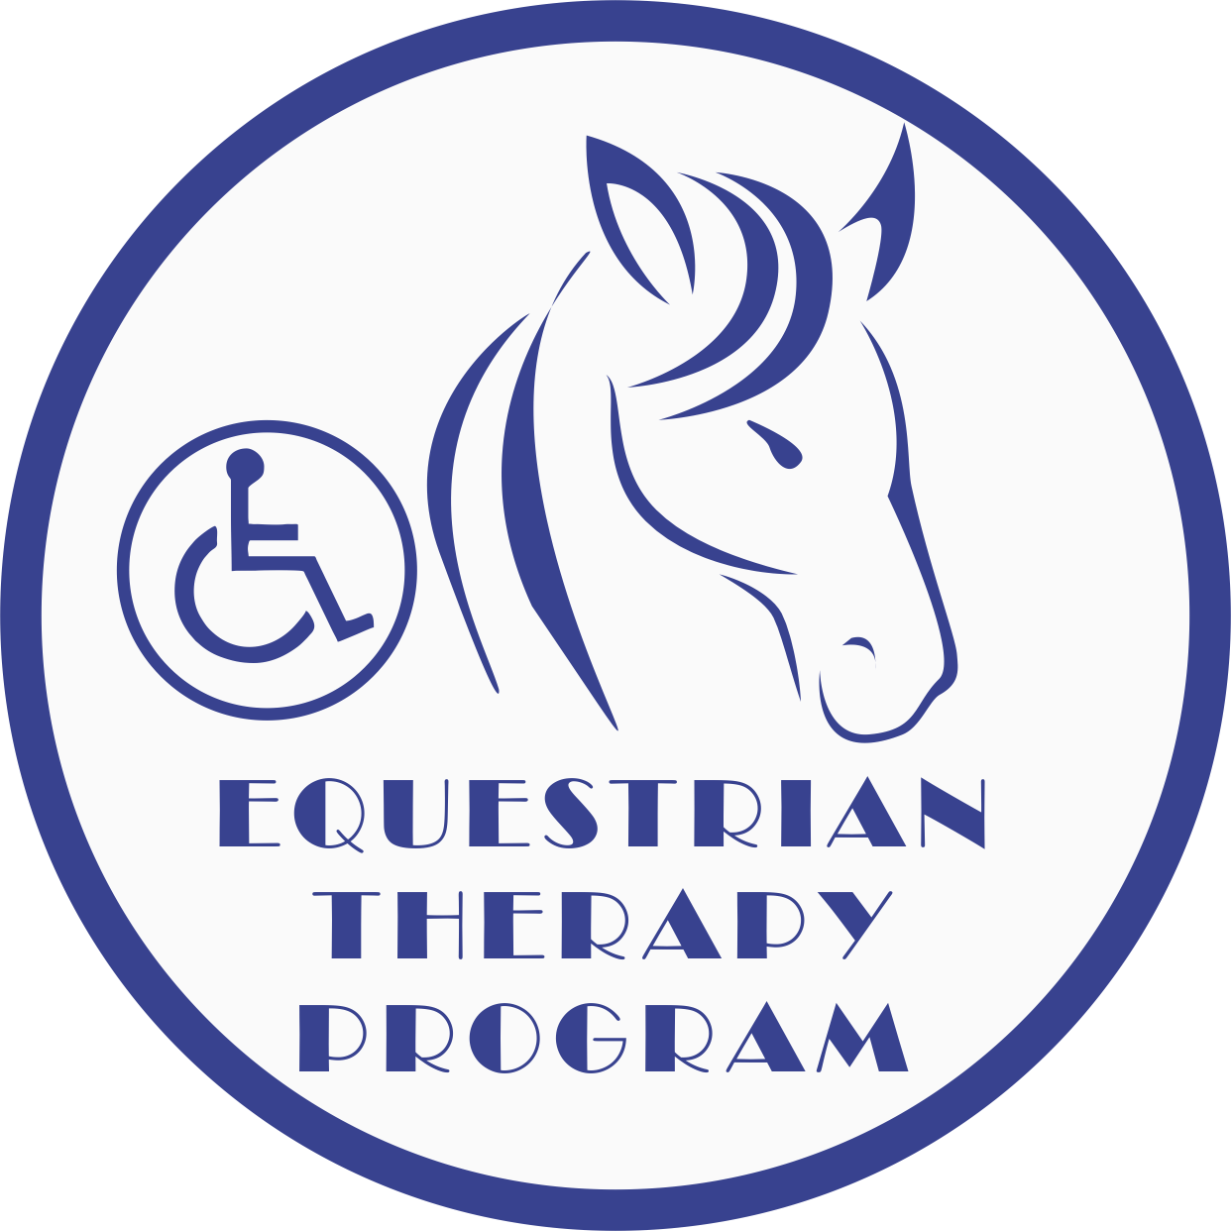
The Equestrian Therapy Program
Equine University
Rider Information and Health History

Student Name: _________________________________________________________
Parent/Guardian: ________________________________________________________
Address: __________________________________________ City:_______________________
State: ___________ Zip Code: ___________ Email:___________________________________
Phone: _________________________________ Cell:__________________________________
Parent/Guardian address (if different from above): ___________________________________
Caregiver: _________________________ Phone: ________________________________
Please contact named individual in the event of a cancellation if different from student’s phone number. Name: ______________________ Phone: ___________________________

Gender: M F DOB: ______________ Weight: ___________ Height: ____________
Allergies and Medications: _________________________________________________________________________________________________________________________________________________________________________________________________________________________________________________________________________________________________________________________________________________________________________________________________
Other Health Conditions: ________________________________________________________
___________________________________________________________________________________________________________________________________________________________________________________________________________________________________________________________________________________________________________________________________________________________________________________________________________________________________________________________________________________________________________________________________________________________
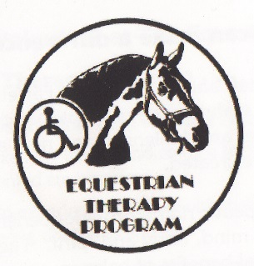
The Equestrian Therapy Program

Emergency Medical & Consent Form

Students Name: _______________________________________________________________

Parent(s)/Legal Guardian(s): _________________________________________________________________

Physician’s Name: _____________________________________________ Phone: _____________________

Address: _____________________________ City: ___________________ State: ______ Zip: _____________

Preferred Medical Facility: _________________________

Health Insurance Co. ____________________________________ Policy # __________________________

Person who is authorized to give temporary assistance or care in the absence of parent or guardian:

Name: ___________________________________ Phone: __________________ Relation: ______________

Consent
In case of medical emergency, the undersigned authorizes Equestrian Therapy Program to provide such medical assistance as they determine to be necessary,
I hereby give my consent, in the event that all reasonable attempts to contact me have been unsuccessful, to the administration of any treatment deemed necessary by or the transfer to the student to ________________
(preferred hospital) or any hospital reasonably accessible. This authorization does not cover major surgery unless the medical opinions of two other licensed physicians or dentists concur in the necessity to such surgery and are obtained prior to the performance of such surgery.

Date: ___________ Consent Signature: _______________________________________________________
(Student if over 18, Parent/Legal Guardian)

Witness: ______________________ _____________________________________________________
(Parent/Legal Guardian)
Participants under age (18) must have this form signed either by both natural parents, or by the sole parent having legal custody, or by the participant’s legal guardian.
Non Consent
I do not give my consent for emergency medical treatment/aid in the case of illness or injury during the process of receiving services or while being on the property or The Equestrian Therapy Program.
__ Parent or Legal Guardian will remain on site at all times during equine assisted activities.
__ In the event emergency treatment/aid is required, I wish the following procedure to take place.

_____________________________________________________________________________

Date: ___________ Non-Consent Signature: ____________________________________________________
(Student if over 18, Parent/Legal Guardian)

Witness: _________________________ ___________________________________________________
(Parent/Legal Guardian)
Participants under age (18) must have this form signed either by both natural parents, or by the sole parent having legal custody, or by the participant’s legal guardian.
3/28/11

May 12, 2020 COVID-19 Liability Waiver/Release

The Equestrian Therapy Program
Covid-19 Acknowledgement of Risk and Acceptance of Services
I, _______________________________ (Participant Name), am aware of the risks of contracting Covid-19 while receiving face to face services from The Equestrian Therapy Program at this time of the pandemic outbreak and the Ohio Governor DeWine’s declaration of a “stay in safe” declaration.
I am aware that face to face services increase my risk of contracting and passing on the Covid-19 or Coronavirus and agree to hold harmless The Equestrian Therapy Program, it’s employees, Board of Directors, Volunteers and all other individuals I may come in contact with during this interaction and receiving of services.
I agree to and will follow all guidelines for personal hygiene, personal safety and public safety as recommended by The Equestrian Therapy Program ( See COVID Plan) and my individual provider/practitioner. This may include, but is not limited to, waiting in my vehicle and/or home until I am asked to enter the building/vehicle either in person or via telephone; washing my hands prior to each session; use of hand sanitizer upon request; wiping down surfaces with disinfecting wipes and/or wearing a protective medical mask and/or gloves.
I agree to cancel my services should I have within the previous 24 hours to 2 weeks personally exhibited or have been in contact with someone who has presented with illness including; cough, sneezing, fever, chest congestion or additional signs of potential spread of any virus or bacteria/disease. In addition, I will follow the recommendations of my provider once I have notified them of these risks in regards to my future services during this pandemic.
The Equestrian Therapy Program will engage in regular cleaning and sanitizing of horse tack, grooming supplies ,doors, and frequently touched areas in-between clients and on a daily basis as recommended by the CDC and our contracted Veterinarian for the safety of clients, employees, volunteers and horses.
I am signing under my own free will and choice and agree to follow these and hold harmless all individuals associated with or through my services acquired from Unbridled Hope, Inc.
Client Name: _______________________________________________Date: ____________________
Client Signature: ______________________________________________________________________
Parent/Guardian Name: ________________________________________Date: ______________
Parent/Guardian Signature: _____________________________________________________________
Witness Signature: _____________________________________________________________________

The Equestrian Therapy Program

Photo Release Form

I _______________________ give permission for the Equestrian Therapy Program to take still and moving photographs and films, including television pictures, of our son/daughter/ward/self _________________________________________________.
In addition, I consent and authorize the ETP and its advertising agencies, the news media, and any other person or organization interested in the ETP and its work to use and reproduce said photographs, films and pictures, and to circulate and publicize the same by any and all means, including, but not limited to, news-papers, magazines, television, brochures, pamphlets, instructional materials, books, and clinical material.
No inducements or promises have been made to us/me to secure our/my signature(s) to this release other than the intention of the ETP to use said photographs, films and pictures for the primary purpose of promoting and aiding the ETP and its work. The ETP is a nonprofit Ohio corporation.
Date: ___________________
_____________________________ __________________________________
Signature of Witness Signature of Parent(s)/ Guardian
_____________________________ ___________________________________
Signature of Witness Signature of Participant (if over 18)
If you do consent to the above, then this form needs to be signed by the participant, if over age 18, and either by both natural parents, or by the sole parent having legal custody, or by the participant’s legal guardian.
_________________________________________________________________________________________
No Photo
I ___________________________________ do not consent to photos or moving pictures of son/daughter/ward/self.
Date: _____________________
_____________________________ __________________________________
Signature of Witness Signature of Parent(s)/ Guardian
_____________________________ ___________________________________
Signature of Witness Signature of Participant (if over 18)

3/28/11
22532 Bowsher Road · Cridersville, Ohio 45806 · Phone (419) 657-2700 · Fax (419) 657-2887

The Equestrian Therapy Program

Student Guidelines

- The student must be FOUR years of age and have a minimum sitting balance and head control of a 6-month-old. Students who have had a Gran Mal seizure within the last year may not be eligible for horseback riding.
- Our weight limit for riding is determined by assessment and available equine.
- ALL FORMS MUST BE FILLED OUT, SIGNED and returned to us before the student may ride. No student will be permitted to ride without these forms.
- When riding, the student must be in long pants and a sturdy shoe, preferably with heels. SHORTS AND SANDALS ARE NOT PERMITTED due to the possibility of pressure sores, pinched legs or foot injuries. Approved hard hats are required and provided. Please remember to wear hair styles that are conducive to a snug-fitting hard hat. Avoid dangling earrings and other jewelry.
- Please observe all barn rules while at the farm. All family and visitors should stay inside the bleacher/lounge area of the barn unless specifically invited to go to another part of the building.
- Our volunteers give of their time and talent so that you are able to ride. PLEASE let us know AS SOON AS POSSIBLE if you will be unable to attend class so that we can schedule our volunteers accordingly. The numbers to call are:

Office: 419-657-2700 Fax: 419-657-2887
Website: www.etpfarm.org
Email: etpfarm@etpfarm.org or programs@etpfarm.org

During extreme weather, not conducive to riding, we will provide alternative activities. In the event that travel is not advisable we will cancel classes, see WLIO for cancellations or call the office. We will call you at the numbers you have provided on your forms.
- If a student has TWO UNEXCUSED ABSENCES in a session, they will be EXCUSED FROM THE PROGRAM. We have a waiting list of students who would like to ride.
- If we determine that this type of riding therapy is not suitable for a student because of safety to the student, volunteer, instructor, horse, or for any other reason, we reserve the right to deny riding to that student.

Thank You for Your Cooperation,

The Equestrian Therapy Program Staff

3/12/2014

22532 Bowsher Road · Cridersville, Ohio 45806 · Phone (419) 657-2700 · Fax (419) 657-2887

The Equestrian Therapy Program

Barn Rules

- Riders must wear a helmet when mounted and working with a horse.
- No chewing gum while mounted.
- Everyone is to walk quietly through the barn, without running.
- Always walk around the head of the horse, not behind.
- Respect all persons, animals and property.
- Students (adults and youths) must always stay with an instructor, volunteer, or teacher when going beyond waiting area.
- Treats can only be fed to the horses with instructor permission and with the help of a volunteer. No feeding from your hand only use Treat Bowls.
- Students must wear long trousers that fit neatly and sturdy closed-toed shoes.
- Indoor voices and appropriate language must be used at all times.
- Pet the horses on the neck or shoulder – not the face. Approach them in a slow quite manner.
- Listen to the instructor and follow directions carefully.
- Staff, volunteers, and participants will silence their cell phones during equine assisted activities and/or while handling equines. Under no circumstances will staff, volunteers, or participants answer their cell phones during equine assisted activities or while handling equines.
3/13/14
22532 Bowsher Road · Cridersville, Ohio 45806 · Phone (419) 657-2700 · Fax (419) 657-2887

